2018 Practice SAC 1/ 2017 SAC
AN INVESTIGATION INTO OBESITY RATES

Researchers have been interested in studying the obesity trends worldwide over the past 25 years.
In 2014 the World Health Organisation (WHO) declared there were 1.6 billion overweight adults worldwide and 600 million of those are considered obese. Due to the concerns related to obese related diseases such as diabetes and heart diseases it has been of interest to see which countries are increasing and decreasing in obesity rates.
This task looks at the obesity rates in 1990 and 2010 for 26 randomly selected countries. The rates are percentages and are based on the total adult population for that country.

Is there a connection between a country’s obesity rate in 1990 and 2010?
Is it possible to predict the trend of a country’s obesity rate?
How has obesity changed in Australia over the past 16 years?

These questions and others are the focus of the task.

Using the data on the coloured paper to answer the following investigation questions.

Table 1: Obesity Rates
 | OBESITY RATE %
Country | 1990 | 2010
Australia | 19.20 | 27.40
Austria | 8.90 | 22.90
Belarus | 18.30 | 17.20
Brazil | 6.80 | 12.40
Canada | 12.90 | 27.70
Chile | 10.90 | 19.30
China | 1.00 | 11.90
Congo | 2.20 | 2.40
Cuba | 2.60 | 19.60
Finland | 19.80 | 20.50
India | 2.40 | 10.90
Iran | 2.40 | 14.60
Japan | 1.70 | 3.70
Morocco | 4.20 | 6.00
Netherlands | 8.40 | 10.30
New Zealand | 13.80 | 32.00
Nigeria | 6.40 | 6.40
Oman | 10.40 | 16.80
Russia | 7.00 | 10.20
Saudi Arabia | 26.30 | 24.00
Sweden | 9.00 | 14.00
Thailand | 2.90 | 4.60
Tunisia | 6.60 | 13.20
Turkey | 7.70 | 15.20
USA | 27.60 | 41.90
Venezuela | 6.60 | 34.10

Table 2: Average Obesity Rates
Year | Obesity Rate per 100,000
2000 | 5.3
2001 | 5.8
2002 | 6.3
2003 | 6.0
2004 | 6.7
2005 | 6.9
2006 | 6.6
2007 | 7.6
2008 | 7.3
2009 | 8.0
2010 | 8.7
2011 | 8.3
2012 | 9.0
2013 | 9.7
2014 | 10.7
2015 | 10.3
2016 | 11.2

Graph 1: Obesity Rates

Part One: Is there a trend between obesity rates from 1990 and 2010?
- Calculate the five number summary statistics and IQR for the 1990 and 2010 obesity rates, correct to 1 decimal places.
 | 1990 | 2010
(3 marks)
(O3)
- Conduct an outlier test for the 1990 and 2010 obesity rates. Explain why/why not there is an outlier present, if one is present, state the value.

(4 marks)
(O1, O1, O2, O2)

- Construct parallel boxplots on the axis below for the 1990 and 2010 Obesity rates (%).
Label each boxplot clearly.

(4 marks)
(O1)
- Compare and contrast the obesity rates from 1990 and 2010. Ensure you are making reference to the shape, centre, spread and quartiles of each year.

(4 marks)
(O2)
- Which measure of centre would be most appropriate to describe the central tendency of each data set (1990 and 2010)? Explain.

(2 marks)
(O2)
Part Two: Comparing obesity rates in 2010.
- Determine the mean and standard deviation of the obesity rates in 2010 and place the values in the table below. Round all values to 1 decimal place.
2010
Mean
Standard Deviation
(2 marks)
(O2)
b) Construct a histogram of the 2010 Obesity rate, with a width of 5. Label the scale on the axes below.

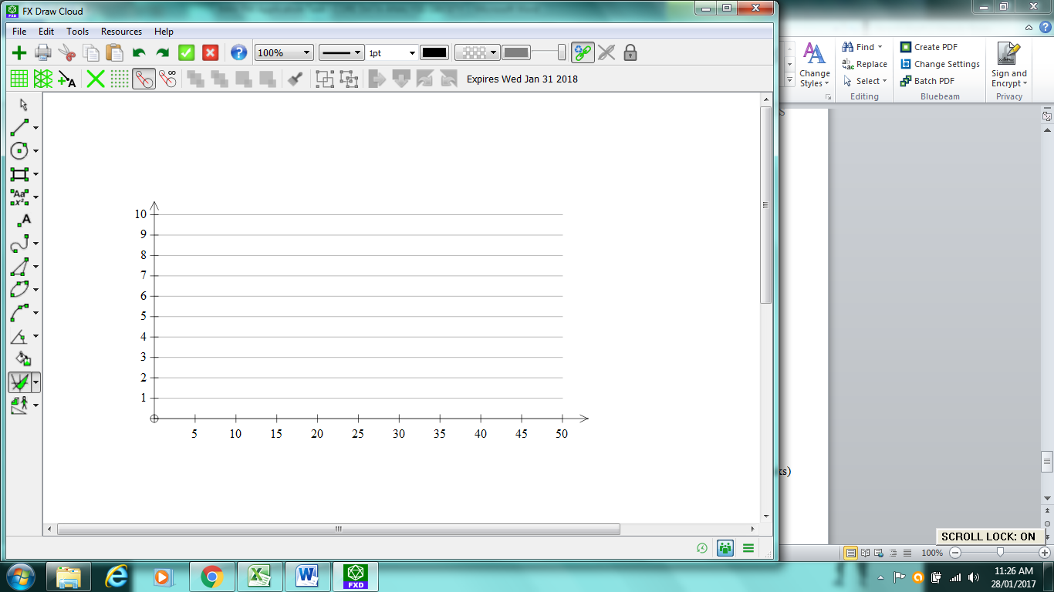
(2 marks)
(O1, O3)
c) Describe the shape of the histogram.
(1 mark)
(O1)
d) What percentage of countries have an obesity rate higher than 10$\%$ in 2010? State your answer to 2 decimal places.
(1 mark)
(O2)
e) Why would it not be suitable to calculate the z-score for Australia in 2010?

(1 mark)
(O2)
Part Three: Regression Analysis
Below is a scatterplot showing the relationship between the obesity rates for 1990 and 2010 for the 26 countries listed in the data sample.
- Write down the explanatory and response variables.
(1 mark)
(O1)
- Determine the equation of the least squares regression line for the scatterplot above. Write the equation in terms of the variables in the form $y=a+bx$ and state the coefficients correct to 3 significant figures. (Also write this equation in the space provided on your coloured data sheet)

(3 marks)
(O1, O2, O3)
- Draw the least squares regression line found in part (b) on the scatterplot above. State the two points used to draw this line.
(2 marks)
(O1, O2)
- Interpret the slope of this least squares regression line in terms of the variables 1990 obesity rate and 2010 obesity rate.
(1 mark)
(O2)
- Interpret the vertical intercept of the least squares regression line in terms of the variables 1990 obesity rate and 2010 obesity rate.
(1 mark)
(O2)
- Calculate the residual values to 1 decimal place in the following table for each country then plot on the axis provided on the next page.

1990 obesity rate | 19.2 | 8.9 | 18.3 | 6.8 | 12.9 | 10.9 | 1 | 2.2 | 2.6 | 19.8 | 2.4 | 2.4 | 1.7
2010 actual obesity rate | 27.4 | 22.9 | 17.2 | 12.4 | 27.7 | 19.3 | 11.9 | 2.4 | 19.6 | 20.5 | 10.9 | 14.6 | 3.7
2010 predicted obesity rate
Residual value

1990 obesity rate | 4.2 | 8.4 | 13.8 | 6.4 | 10.4 | 7 | 26.3 | 9 | 2.9 | 6.6 | 7.7 | 27.6 | 6.6
2010 actual obesity rate | 6.0 | 10.3 | 32.0 | 6.4 | 16.8 | 10.2 | 24.00 | 14.0 | 4.6 | 13.2 | 15.2 | 41.9 | 34.1
2010 predicted obesity rate
Residual value

(Table = 3 marks O3) (Plot = 3 marks O1)
g) What does the residual analysis say about the original data?

(1 mark)
(O2)
h) Which country had the largest difference between the predicted 2010 and actual 2010 obesity rate?
(1 mark)
(O2)
i) Calculate the correlation coefficient (r) for the 26 countries correct to 3 decimal places and comment on what this indicates about the relationship between the prevalence of obesity in 1990 and in 2010.

(2 marks)
(O1, O3)
j) Calculate the coefficient of determination (r²) for the 26 countries correct to 3 decimal places and comment on what this indicates about the relationship between the prevalence of obesity in 1990 and in 2010.

(2 marks)
(O2, O3)
Part Four: Transforming the data
In an attempt to improve the linearity of the data, we will look at different transformations.
- Suggest three possible transformations
(1 marks)
(O2)
- Apply each of the 3 transformation to your data. Complete the table below for the transformed data values. Use y to represent 2010 obesity rate and x to represent 1990 obesity rate in your equations. Round all values to 2 decimals places
Transformation | Equation of least squares regression line | Correlation Coefficient
(6 marks)
(O2, O2, O2, O3, O3, O3)
- Comment on the improvement or otherwise of each transformation equation over the original equation you found in 3b. Use mathematical reasoning to support your comments, choose the best equation for calculating predicted values from the four equations considered (original from Q3b, plus 3 transformations).

(2 marks)
(O2)
- Re-write your given equation, in terms of the variables given.

(1 mark)
(O2)
- Use your chosen equation to predict a country’s obesity rate in 2010 if it is 9.2% in 1990.
Round your answer to the nearest whole number.
(1 mark)
(O2)
- Use your chosen equation to predict a country’s obesity rate in 2010 if it is 31% in 1990.
Round your answer to the nearest whole number.
(1 mark)
(O2)
- Which prediction from part e) and f) is more reliable. Explain

(2 marks)
(O2)
Part Five: Time Series
The time series graph below shows the obesity trend in Australia from 2000-2016 per 100,000 people.

- Use this time series graph to describe the trend of the obesity rates in Australia from 2000 to 2016.

(1 mark)
(O1)
- Smooth the graph above using a 3 point median smoothing graphical method. Mark in your points using an X in blue pen.
(2 marks)
(O2)
- Use the table below to complete a 3 point moving mean. Round all values to 1 decimal place.
Year | Obesity Rate per 100,000 ppl | 3 point moving mean
2004 | 6.3
2005 | 7.5
2006 | 7
2007 | 6.8
2008 | 7.4
2009 | 8
2010 | 8. 5
2011 | 7. 5
2012 | 8.8
2013 | 9.4
2014 | 9.1
2015 | 10.8
2016 | 11.3

(2 marks)
(O1, O3)
- Plot the 3 point moving mean data onto the scatterplot above. Mark points as asterisks * using a red pen.
(2 marks)
(O1)
- Comment on the effectiveness of the two smoothing techniques to identity any trends.

(1 marks)
(O2)
Part Six: Displaying Data
1a Represent the data for Average obesity rates (from Table 2) in an ordered stem and leaf plot.

(3 marks)
(O1)
g) What implications does this data have for the overall health of these nations with respect to time?

(1 mark)
(O2)

